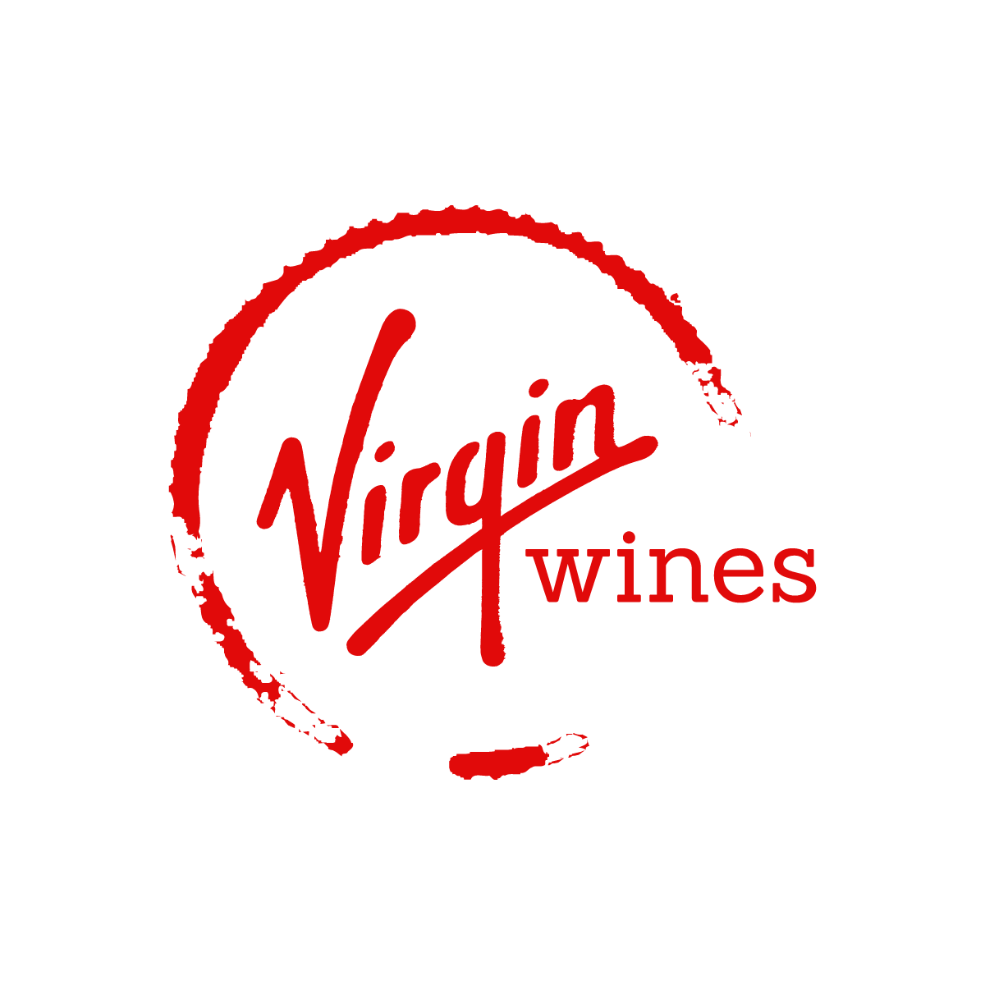  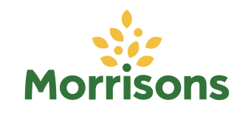      Online wine market  COMPETITOR ANALYSIS | SMM750 Group Assignment  Group 5  Linh Nguyen (170037344)  Soumya Ogoti (220045527)  Wenxu Tian (210059418)  Aparna Viswanathan (220004767)  Fan Xia (200039922)

Table of Contents

Research scope 2
1. Data acquisition 3
2. Data cleaning 3
3. Variable description 5
4. Summary statistics of all and each retailer 7
5. Results and Analysis 9
5.1 Price range in wine types within the 4 retailers 9
5.2 Top 5 most reviewed countries of origin by retailer 11
5.3 Top 5 most reviewed ABV categories by retailer 12
5.4 Top 5 most reviewed wine age categories by retailer 13
5.5 Top 5 most reviewed price categories by retailer 13
5.6 Top 5 most reviewed wine types by retailer 14
5.7. Conclusion 14
6. Web scraping challenges and solutions 15
6.1. Anti-scrapping 15
6.2. Varying web page structures 15
6.3. Website crashes 16
6.4. Poor data quality 16
References 18

Research scope
During the pandemic period, the global beverage market was under a negative impact due to the closure of restaurants, bars, and clubs, as well as a sharp decrease in the tourism sector. However, the boost in e-commerce sales has partly offset the adverse trend in the wine industry (Wittwer & Anderson, 2021).
To establish a preliminary understanding of the wine market, the analytics team investigated online wine consumer purchasing behaviour through the operations of current competitors in the market. The reasons for online wine shopping can be categorised into three aspects: cheaper prices, detailed product descriptions, and more options available in online shops (Bonn et al., 2016; From The Vine, 2022). In this case, we have determined that our analysis of the wine market would be based on information surrounding wine features (including wine type, country, year, and ABV), price (for a bottle of 75cL), and reviews (including the number of reviews and scores) which would be collected from competitors’ websites for analysis.
To be clearer, the key objectives are to (1) identify the most popular wines sold across the companies and the key features of best-selling wines; (2) identify the most frequent price ranges for wines in order to learn product portfolio and business focus (e.g. how much should be invested on mass-market wines and niche-market wines respectively in our e-commerce shop). Therefore, we have utilised the Python libraries BeautifulSoup and Selenium to collect data from the competitor websites.
Given the fact that this online wine shop plans to target a broad market scope with various wine options, the team carefully selected four online retailers who provide wines in a variety of selections with detailed product descriptions which can be utilised for the analysis. The four companies are Laithwaites, Virgin Wines, Decantalo and the wine section page on Morrisons website. To be more specific, our team selected Morrisons wine as a good representative of mass-market wine retailers as they mainly target consumers with a limited budget. In addition, Virgin Wines is also considered because unlike Morrisons, Virgin Wine not only has cheap wines but also sells middle-end wines which are priced over £100. Laithwaites, which provides wines from £2 to £1,400 is also considered to be valuable in this case as the fine wines in its product offering will improve the analysis accuracy. Finally, apart from all three British brands mentioned above, other markets outside of the UK are also considered. A retailer named Decantalo which is based in another significant wine market, Spain is analysed on the ground that it offers products to an international market.

Data acquisition
After identifying the research purpose and important variables for our analysis, as mentioned above, the following websites were selected as our data sources:
- https://www.laithwaites.co.uk/wines
- https://www.virginwines.co.uk/
- https://www.decantalo.com/uk/en/wine/
- https://groceries.morrisons.com/browse/beer-wines-spirits-103120/wine-champagne-176432
Those websites were chosen not only because of their companies’ positions in the online wine retail market but also because their websites contain sufficient information that we require for our analysis. They also, to some extent, have a consistent structure for wine listings, which may facilitate scrapping. In this project, only web scraping is considered due to the concentration on the price ranges and product catalogues of the competitors.
Our main method is to use Selenium to access the web pages and collect the URLs to each product listing. Then, we used Python’s “requests” library to get the content from the web page and extract relevant information.
Most of the data cleaning was also done at this stage since the context surrounding the data is already available which made debugging much easier. The challenges and solutions during the web scraping process will be discussed further in this report.

Data cleaning
In this part, we:
- Analysed the missing values to find out the underlying causes. We have found that values could be missing for different reasons, for example:
  - Prices: The product is out of stock
  - ABV: The product is a collection instead of a single bottle
  - Year: The product is non-vintage
  - Size: The size needed to be inferred, e.g., Magnum is short for 1.5L
  - Rating: The product did not receive any reviews
  - The information is simply not available on the product page

- Analysed the values’ distributions by plotting histograms and the set of values available. This process identified extreme outliers (a >£26,000 bottle) and incorrect information (a product with an ABV of >1000%).
- Changed the price column type from object to float64.
- For the column country, we:
  - corrected and standardised the country names (e.g., “: Portugal” → “Portugal”, “U.K” → “UK”
  - Inferred the country names: “Cahors” → “France”, “Produce of the EU” → “EU”
  - Filled the missing values with “unknown”

- For ABV values, since ABV takes values between 0 and 100% the rows with values larger than 100 were dropped. We also checked the total number of missing values in ABV and found that it was not significant (<1%), so those rows were also dropped from the analysis.
- For missing values in the year column, it is observed that the percentage was 5%, hence, we decided to keep these rows to use the other column values for further analysis of the data.
- Standardised wine types, e.g., “Red wine”, “Red”, “Red Wine”, etc., are replaced with “Red”.

After this stage, we obtained datasets with the variables mentioned in the next part. The details of our relevant features engineering are also discussed. The codes for the scraping and cleaning part were carefully reviewed and updated to be the most efficient before all datasets were merged. The last step is visualizing the key features of our datasets to achieve meaningful insights for our business.

Variable description
In this section, a table of variable descriptions is presented to explain the variables in more detail.
Table 1. Variable Description
Variable | Description | Unit
name | Name of the wine
country | Country of the wine’s origin
country_code | Country code of the wine’s origin
wine_type | Type of the wine, e.g. red wine, white wine, sparkling wine, rosé wine etc.
year | Year when the grapes for the wine were harvested | Years
price_fixed | Listed price of the wine per bottle | Price in GBP (£)
logprice | Log price of the wine per bottle | Price in GBP (£)
scaled_price | Scaled price of the wine to 75 cL | Price in GBP (£)
score | Rating score of the wine | Lowest (0) to highest (5) rating
num_review | Number of reviews of the wine | No. of reviews
abv | Alcohol by volume, which measures alcohol content of wine | Percentage (%)
age | Age of the wine which is calculated by deducing year from current year (2022) | Years
size(cL) | Volume of the wine | cL

In terms of ratings, for wines with less than 5 reviews, the ratings are not considered in our analysis as the number of reviews was not sufficient to justify. In this case, all the wines with less than 5 reviews have a rating score of 0.
Furthermore, since there are extreme outliers in the wine prices, the log of prices is taken to visualise the price distribution of different wines to address the skewness in price data.
As the bottle sizes vary among wines, to compare prices of wines on a fair basis, the team scaled the prices of the wine to 75cL which is the most common size of wine bottles. Besides, the age of wines is calculated by deducting year when grapes were harvested from the current year (2022).
For the wine type, apart from the main types such as red, white, sparkling and rose, there are some other wine types such as orange and sherry which account for a relatively small percentage. Therefore, other wine types except red, white, sparkling and rose are categorised as “others” for further analysis. Lastly, since there are a number of unique country values, a new column for country codes was added for cleaner visualisation.

Summary statistics of all and each retailer
Table 2. General information of 4 retailers
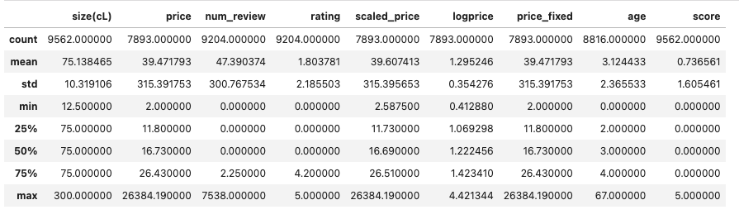
Table 3. Laithwaites
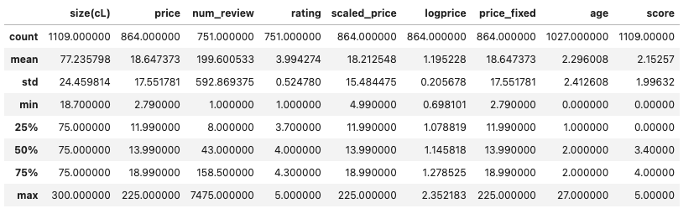
Table 4. Morrisons
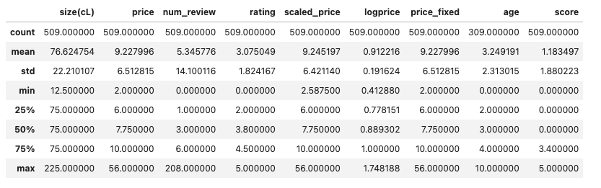
Table 5. Virgin Wines
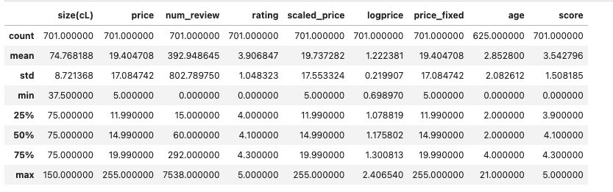
Table 6. Decantalo
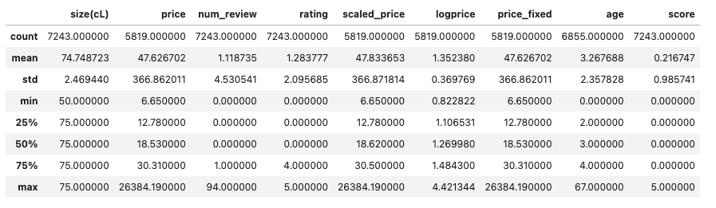

Results and Analysis

5.1 Price range in wine types within the 4 retailers
Listed price | Log-transformed price
Figure 1 - Decantalo | Figure 2 - Decantalo
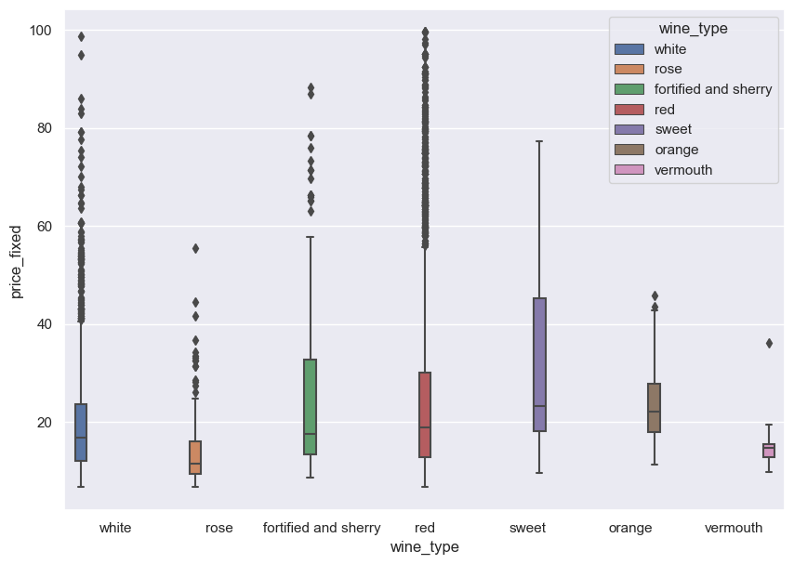 | 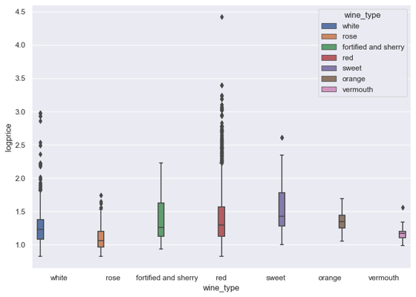
Figure 3 - Laithwaites | Figure 4 - Laithwaites
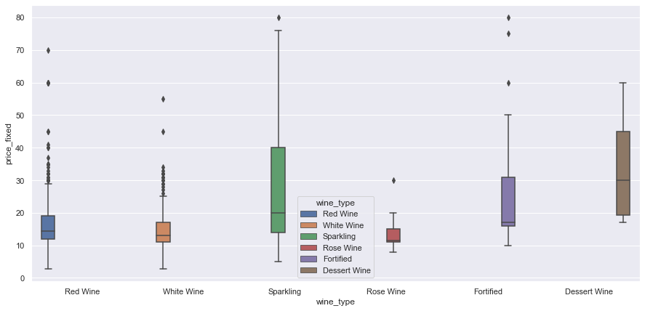 | 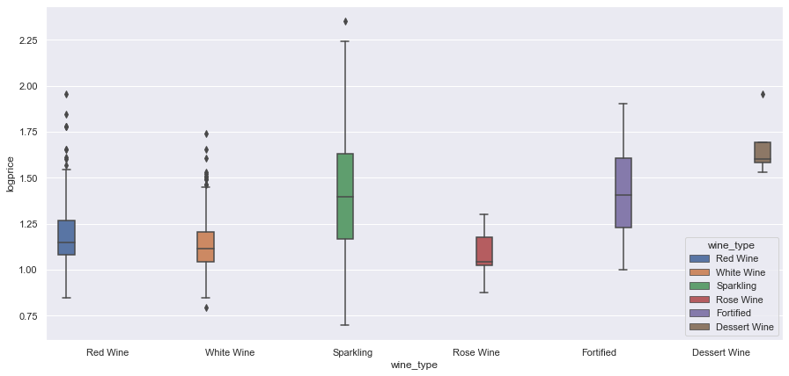
Figure 5 - Morrisons | Figure 6 - Morrisons
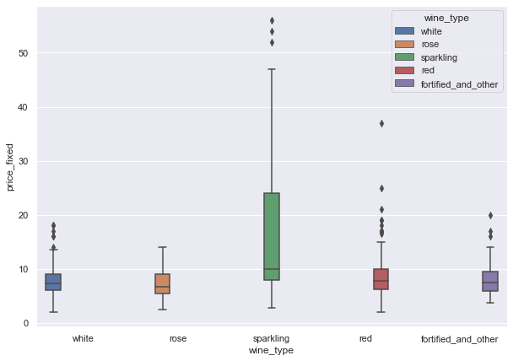 | 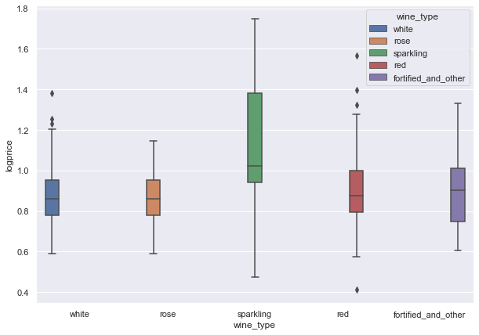
Figure 7 - Virgin Wines | Figure 8 - Virgin Wines
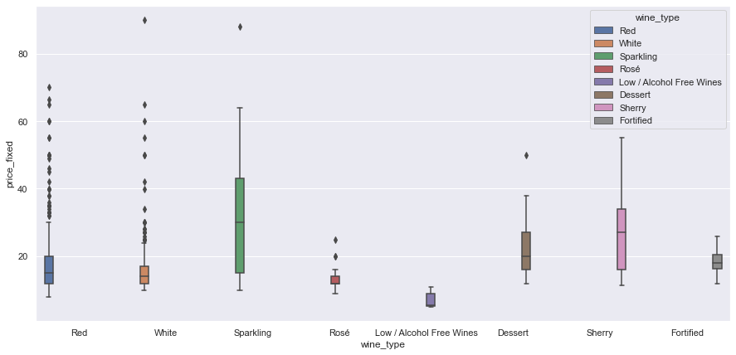 | 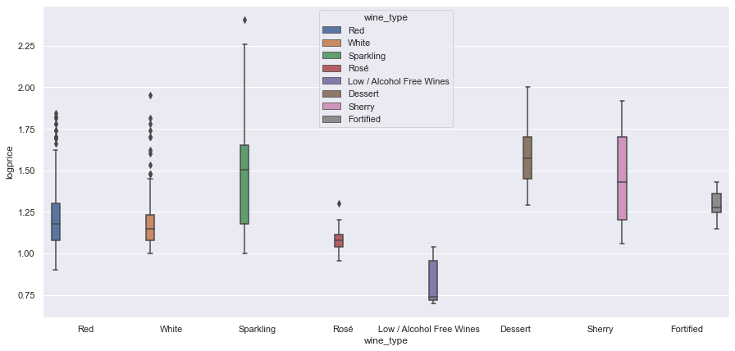

The figures above show the listed and log-transformed prices by wine type of all retailers. In the visualisations for listed prices, only prices below £100 per bottle were included so the boxes can be visible. This is also the range that our company considers focusing on to target the public.
Among all the wine types, red wine has a wide price range in the case of Decantalo while it is sparkling wine in the case of the others. In particular, it is demonstrated in the log price plots that Decantalo has the widest price range with products’ prices at an outstandingly higher level than others with the highest price per bottle being around £26,000.
Decantalo’s average price per bottle is the highest being approximately £47. Virgin Wines and Laithwaites focuses on the middle price range with an average price of £19 and only sparkling type having some expensive products. Morrisons consistently stays in lower price range with the average price at £9, and only its sparkling type has some more expensive products, but the highest prices are still generally lower than in other retailers.
Therefore, we can conclude that although the price range in wine types varies from brand to brand, it is highly associated with the company’s brand positioning and marketing target. The business scope and focus of the online wine shop should be carefully considered before determining the price range for each type of wine.
To identify the main product ranges for each retailer, it is natural to consider the volume sold or revenue of each product range. However, such information is not readily available. Therefore, we have decided to use the number of reviews as a proxy for a product’s popularity. By this, we assume that the more reviews a product has, the more popular it is, and the more likely it is one of the main products of a retailer.

5.2 Top 5 most reviewed countries of origin by retailer
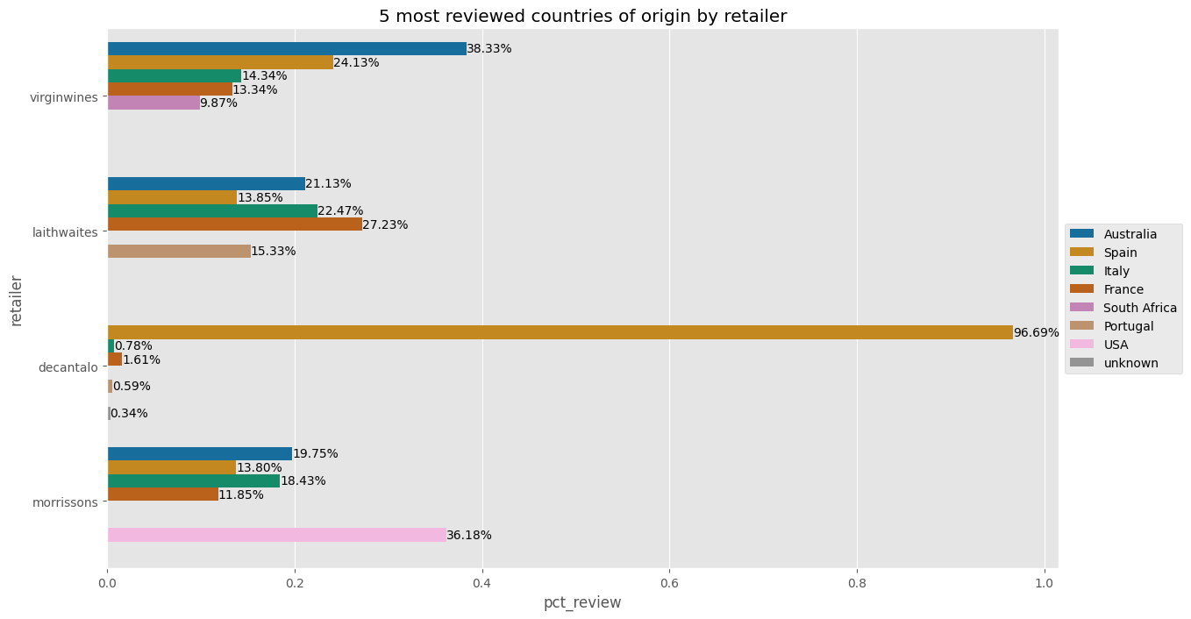
This bar chart shows the top 5 countries with wines being mostly reviewed on 4 retailers’ websites by percentage. The chart suggests that Australia, Spain, Italy, and France are consistently the most popular wine origins. Interestingly, the USA is significantly more popular in the case of Morrisons compared to the other retailers.
Although the aim of plotting this chart is to identify which countries produce the most popular wine from the 4 retailers’ data, the results can be significantly biased by the company’s own product basis and only reflects the retailer’s choice of wine instead of consumers. Taking Decantalo as an example, it is observed that the majority of wines sold on this platform were produced in Spain. This makes sense because Decantalo is a Spanish retailer.

5.3 Top 5 most reviewed ABV categories by retailer
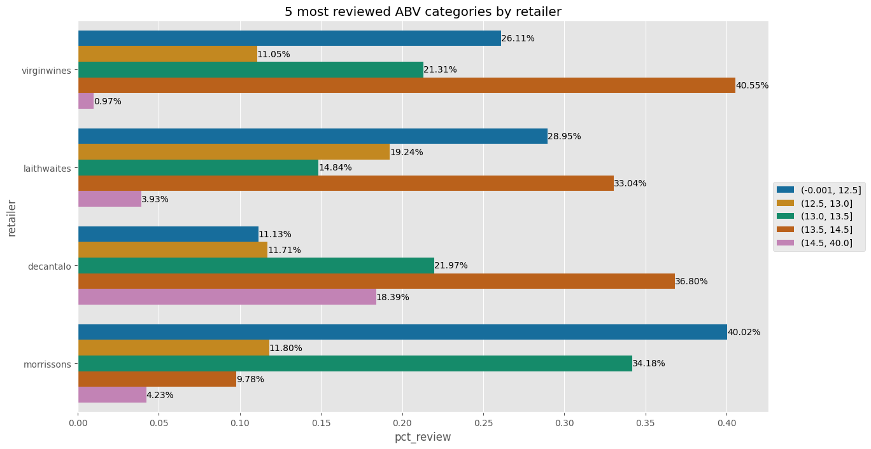
This graph shows the top 5 most reviewed ABV categories by retailer. The ABV values are binned into 10 deciles for ease of analysis.
It is clear to see that for most of the retailers, ABV with a range below 12.5% and between 13.5% to 14.5% is generally preferred by consumers as those wines get most reviews. However, the distribution is not the same across retailers. For example, Morrisons’ most reviewed wine range has less than 12.5% ABV while the same range only ranked 5th in the case of Decantalo. It would be interesting to investigate further into this: Is it because of the difference in pricing, or country of origin?
Also, further investigation can be conducted by the marketing team to learn the market needs, for example, are wines with no more than 12.5% ABV more preferred by female consumers? After obtaining more information, a detailed promotion strategy can be implemented to boost sales.

5.4 Top 5 most reviewed wine age categories by retailer
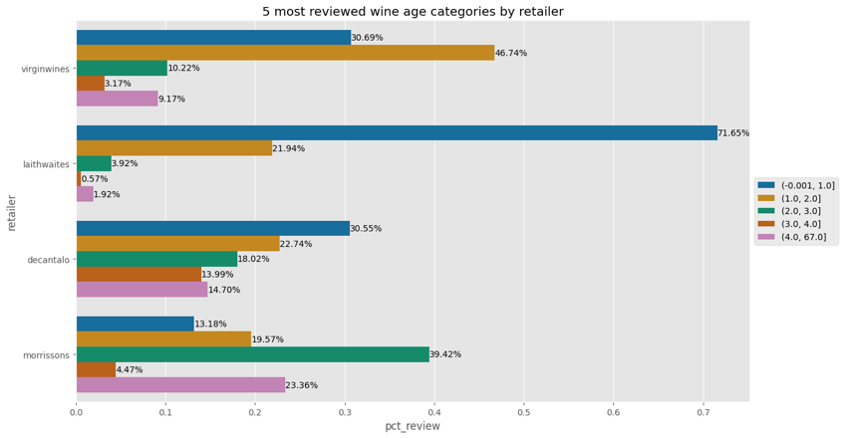
This bar chart indicates the top 5 most reviewed wine age by retailer. Although the age categories vary from retailer to retailer, most of the wines are under 2 years old. This can be explained by the fact that young wines can usually be non-expensive, which makes them more popular in the mass market. In this scenario, it can be implied that if our shop concentrates on mass-market wine sales, then young wines could be paid more attention.
Interestingly, Morrisons’ older wines received more reviews than the other categories, which is not true for the remaining 3 competitors. This might be explained by the fact that they generally price their wines lower than the other competitors, which makes their older wines more accessible to the mass market.

5.5 Top 5 most reviewed price categories by retailer
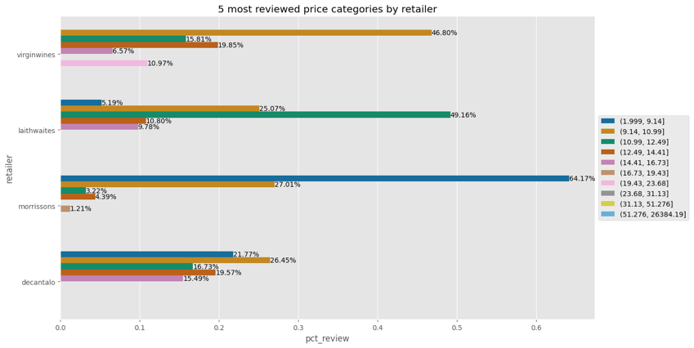
The findings in this bar chart clearly demonstrate the market positioning of these four selected retailers, as Morrisons’ most popular wines are priced at the lowest among the four retailers, while Virgin Wines and Laithwaites focus more on the middle market. Finally, the price ranges at Decantalo are distributed on a more equal basis.

5.6 Top 5 most reviewed wine types by retailer
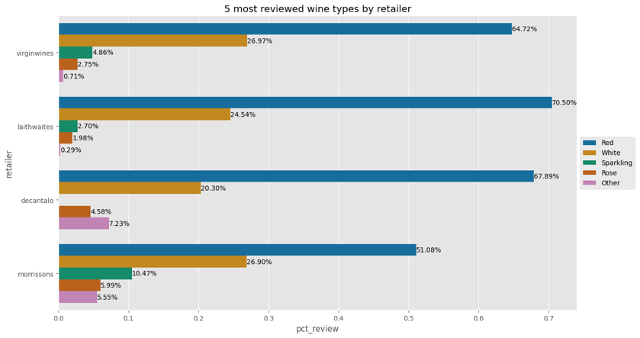
From the chart shown above, it is undeniable that among most wine retailers, red wine is ranked to be the most popular type, followed by white wine and sparkling wine. Rosé wine is the fourth most favourable wine by the majority.

5.7. Conclusion
Overall, it can be concluded that in our business scenario, while considering the product portfolio of the e-commerce wine shop, it is recommended to consider purchasing the major types of wine such as red wine, and white wine to be the main product offering.
Additionally, wines with ABV below 12.5% and between 13.5% and 14.5% are more popular. To maximise the profit, while considering the pricing strategy, the results of the most reviewed price categories can be considered along with the cost factors to set a reasonable price range for our products.

Web scraping challenges and solutions
During the data collection process, we encountered four main problems: Anti-scrapping, varying web page structures, sudden crashes, and poor data quality.

6.1. Anti-scrapping
There are some retailers who implemented various anti-scrapping methods on their websites. In our case, they were Waitrose Cellar and Ocado.
Waitrose can identify if requests were made from a scrapping engine such as Selenium and actively block them. We have attempted to use a macro tool to simulate clicks on the browser to get the URLs, but Waitrose also blocks GET requests to their product page listings. We have managed to get around this by using the headers sent to Waitrose from a manual browsing session. However, considering getting the URLs is an extremely slow and error-prone process and the wide range of products that Waitrose has, we have decided not to proceed with this retailer.
Like Waitrose, Ocado also blocks scrapping engines, although the method is not as sophisticated as Waitrose. In addition, they intentionally include special characters in the names of the class elements to prevent scrapping. Finally, they state clearly in their terms of use that web scraping is only allowed if there is a data exchange agreement.
This issue was identified at the initial research stage and as a result, Morrisons was chosen as an alternative.

6.2. Varying web page structures
Another challenge we faced is that different websites have different web page structures.
For Morrisons’s website, the product listings are only loaded if the product containers are scrolled to in the browser. Therefore, we needed to use Selenium to maximize the window, scroll down, wait for the listings to appear, and click on “Show more” to show the next batch of products. Meanwhile, for other websites, only clicking the “Next arrow” button was required. In addition, Morrisons’ product listing pages have poor consistency. For example, the country of origin sometimes has a dedicated section, but in other cases, it is specified in the product description with different spellings, e.g., “Product of X”, “Wine of Italy”, etc. In this case, we searched for those keywords from the bottom of the page instead from the top.
For Laithwaites website, year of wine is included at the end of the name of a wine (e.g. Cabalié Cuvée Vieilles Vignes 2021) which can only be found on the heading of the page, while for the other three websites, it is available in the product description. Therefore, for Laithwaites, information regarding year was subtracted from name of the wine in the heading. Also, the product attributes are organised into lists instead of classes, and the lists vary by product. As such, we need to text-match the list description to get the correct product attribute.
For Virgin Wines, the “Next” button is poorly defined which makes simply clicking on the button unreliable. However, we noticed that the page number is encoded in the URL. We have then decided to use a loop to iterate through the listing pages by modifying the page number in the URL.
For Decantalo, the number of reviews is queried with JavaScript from the webpage. As a result, it was not possible to get the information with the ‘requests’ library. We had to use Selenium to render the product page so that the reviews are displayed, which significantly slowed down the scrapping process. This, combined with the fact that Decantalo has 10-15 times more products on their page compared to the other retailers, and their website is slow, one scrapping run alone took more than 5 hours to complete.

6.3. Website crashes
During the scraping process, after the CSV files were saved successfully, a code review was conducted to ensure that our code would run efficiently and that the correct data had been collected. Furthermore, the scraping process was not linear as it involves going back and forth to fix edge cases and debugging.
There were two websites that had sudden crashes which were Virgin Wines and Laithwaites. The only solution in this situation is to either wait for the websites to operate normally or to choose another website, which both required significant extra time and effort. In this project, the crash of Laithwaites lasted for a few hours while it took more than 2 days for Virgin Wines. Hence, although there was a delay, the scraping code could still be reviewed and updated as planned.

6.4. Poor data quality
Some data quality issues were identified as follows:
- Different spelling of product information: For example, bottle sizes are specified in ‘mL’, ‘ml’, ‘cl.’, ‘Magnum’ (which is 1.5L), … For this issue, we had to handle the unit text and convert them to ‘cl’ and converted Magnum to 150cl.
- Wine type not consistent or not listed in the product page. As a result, we started a browsing session for each wine type, and relied on the product classification being correct.
- Incorrect product classification: There were instances of wine cases, and even candles being classified as wine bottles. We keyword-matched the product name to identify such products and excluded them from the analysis.
- Missing information: Where possible, we tried to look in other parts of the websites for the information (in the case of Morrisons). However, this is not always possible. For instance, if a product on Laithwaites or Decantalo is sold out or out of stock then the price value is missing. This method was not reliable due to the unstructured nature of text data and hence does not guarantee the correct information being retrieved.
- Special characters: There were unnecessary spaces or special characters in the product attributes. We simply applied string processing methods to address them.

Dealing with the above issues required a significant amount of trial and error due to the sheer number of edge cases. Overall, we have found that saving the URL with the listing helped us quickly identify and analyse the anomalies, and we could avoid rerunning the scrapping from the beginning by setting up checkpoints during the scrapping run.

References

Bonn, M.A., Kim, W.G., Kang, S. and Cho, M., 2016. Purchasing wine online: The effects of social influence, perceived usefulness, perceived ease of use, and wine involvement. Journal of Hospitality Marketing & Management, 25(7), pp.841-869.

From The Vine, 2022. Shop Smart: Reasons To Buy Your Wine Online. [online] Available at: https://www.wtso.com/blog/shop-smart-reasons-to-buy-your-wine-online/ [Accessed 31 Oct. 2022].

Tanford, J.A., 2006. E-commerce in Wine. JL Econ. & Pol'y, 3, p.275.

Wittwer, G. and Anderson, K., 2021. COVID-19 and global beverage markets: Implications for wine. Journal of Wine Economics, 16(2), pp.117-130.

